Ryan Hatch

SNHU

DAD 220

1-4 Lab: Practicing Query Language in Codio  
  
  
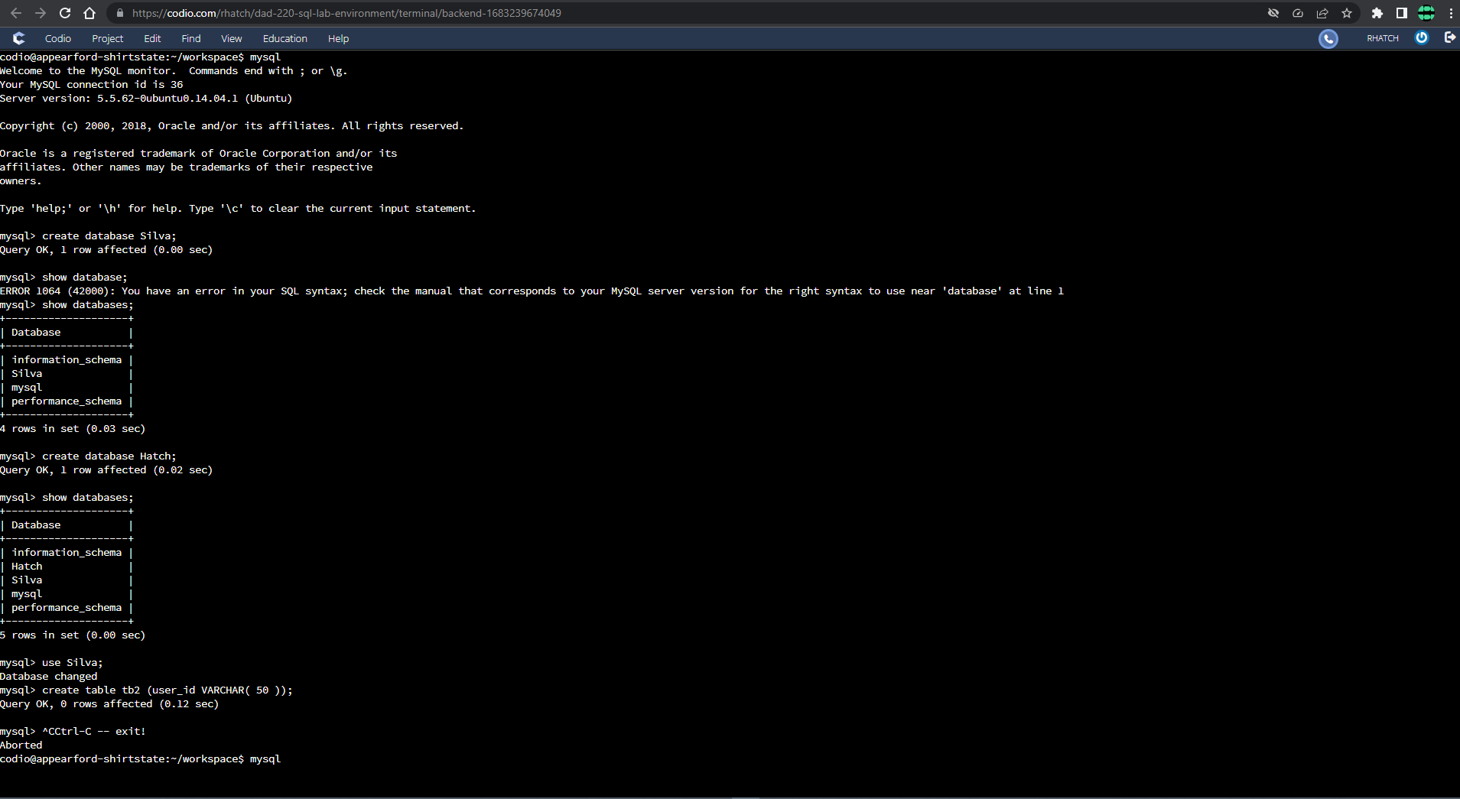  
i: Create a new database  
  
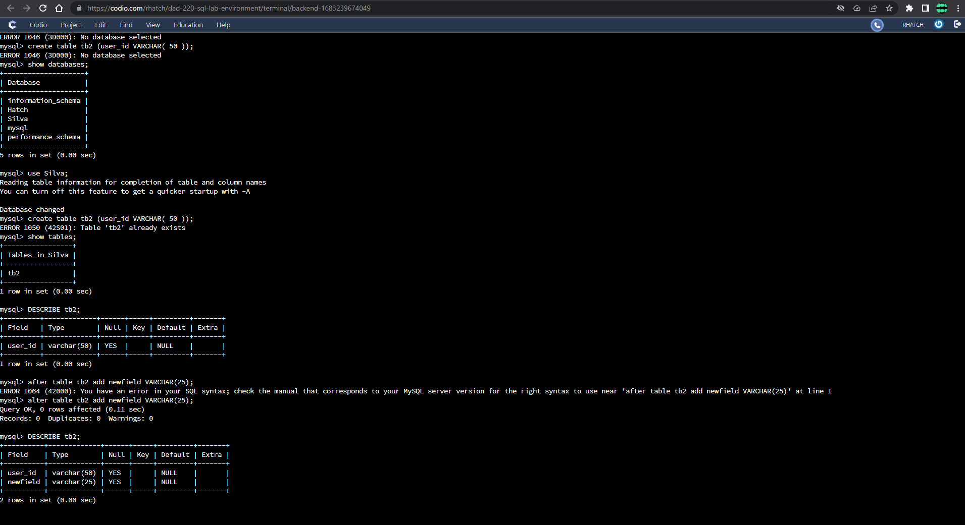  
ii: Create a table called tb2 *and* add a second field into the table and describe it